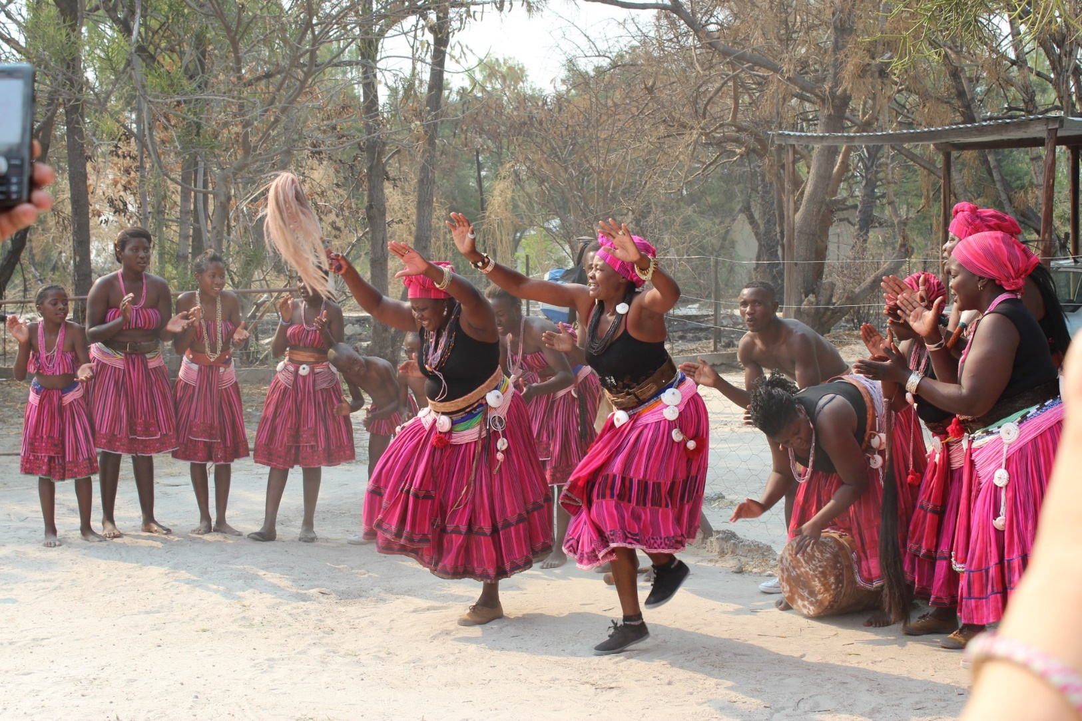

Priscilla S. Masule Maria N. Ntinda Hilma N. Aludhilu

**AN INTERACTIVE BOOK: PRESERVING AAWAMBO CULTURAL DANCES USING Uudhano Wetu AUGMENTED REALITY Mobile APPLICATION**

**Table of Contents**

**Purpose** 4

**Steps on how to use the uudhano wetu application:** 6

**Background** 7

**Omupembe** 8

**Wedding dance** 12

**onkandeka** 14

**References:** 16

# **Purpose**

This book aims to preserve the Aawambo cultural dances by educating the readers about the dances and presenting a video on each dance. The book is embedded with Augmented Reality (AR) technologies, consisting of markers (pictures) which are detected by an AR mobile application and display 3D results (Villarejo, Gonzalez, Miralbell, & Gomis, 2014).

This book describes five Aawambo dances: Omupembe, Uudhano, traditional wedding dance, Onkandeka and Okankula, stating the event were each dance is performed and the gender that performs each dance. In addition, the book presents videos on three of the dances stated prior: Omupembe, Oudano or Uudhano dance and traditional wedding dance. The videos show how the dances are performed and these videos can be viewed using the **Uudhano wetu** mobile AR application. Uudhano wetu mobile AR application can be downloaded from google play and runs on android platforms only.

4

Use uudhano Wetu Mobile Augmented Reality Application to watch videos embended in this book and find out about four Aawambo traditional Dances

5

# **Steps on how to use the uudhano wetu application:**

1. Go to google play.
2. Download Uudhano wetu application.
3. Find the icon on your phone.
4. Click on the Uudhano wetu application.
5. Point to the picture of the dance you wish to watch.

6

# **Background**

Aawambo also known as Ovambo belong to an ethnic group that resides mainly in northern Namibia with some in southern Angola. Aawambo consist of sub tribes: Aandonga, Aakwanyama, Aakwambi, Aangandjela, Aakwaluudhi, Aambalanhu, Aankolonkadhi, and Aabandja. Aawambo is one of the biggest tribes in Namibia and is rich in culture. Although effort has been made to preserve the Aawambo cultural practices, little has been done to preserve the Aawambo cultural dances using technology.

African dances capture the spirit of life events, communities, spiritual beliefs, and identities of tribes and clans of various regions (Kassing, 2014). Aawambo cultural dances are usually performed at social gatherings or rituals and that is how the dances are passed on from generations to generations. These dances have different names, linked to social functions or rituals where they are performed. In this book, the following Aawambo cultural dances: Omupembe, Uudhano, Wedding dance and Okandeka are presented.

7

# **Omupembe**

**Description**: Omupembe is performed mostly among the Aangandjera people and resembles military training practice. During this dance, man jump over other men’s heads. The dance was forbidden in the past by the South African regime of occupation.

**Gender**: Omupembe is only performed by male.

**Where it is performed**: Omupembe is mostly performed at special events like weddings, schools, African day celebrations.

**Video:** Use the Uudhano wetu mobile AR application to watch the video on how the Omupembe is performed.

8

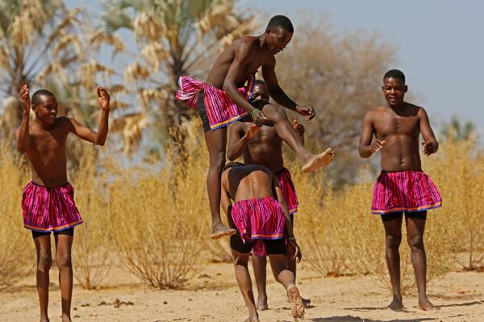

**(Namibia Tourism, 2014)**

**Uudhano**

**Description**: Uudhano is very common within the Ovambo people. This dance is performed in two versions: One version is performed by adult women using slow motion and men are welcomed if they wish so. The other version includes girls dancing in fast motion.

**Gender**: Uudhano can be performed by both male and female

**Where is it performed:**  Uudano is performed at different events, example: independence celebrations.

**Video**: Use the Uudhano wetu mobile AR application to watch the video on how the Oudano or Uudano dance is performed.

10

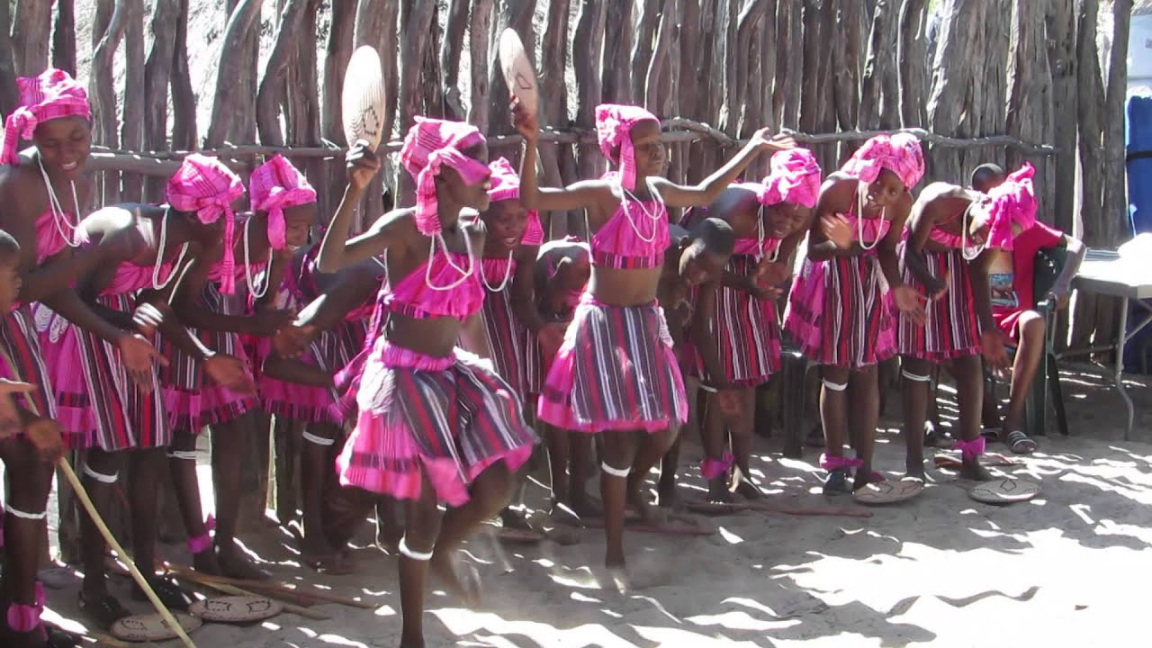

**(Johnson, 2015)**

# **Wedding dance**

**Description**: The Aawambo wedding dance is mostly danced by women, while men don’t really move that much.

**Gender**: Aawambo wedding dance is performed by male and female

**Where is it performed**: The Aawambo wedding dance is usually performed at weddings.

**Video**: Use the Oudhano wetu mobile AR application to watch the video on how the wedding dance is performed.

12

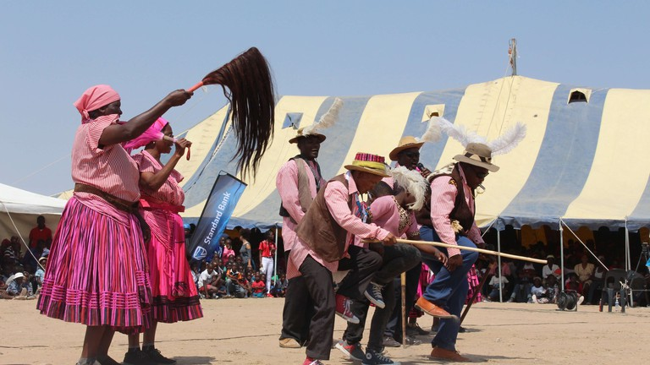

**(Kaakunga, 2018)**

# **onkandeka**

**Description:** Onkandeka is a fighting play performed by young men. The dance is used to test masculinity amongst men and to promote friendship.

**Gender**: Onkandeka is performed by male only.

**Where is it performed**: Onkandeka is mostly performed at the entrance of the cattle kraal and because of its violent nature, it is prohibited by the elders.

**Video**: Use the Oudhano wetu mobile AR application to watch the video on how the wedding dance is performed.

14

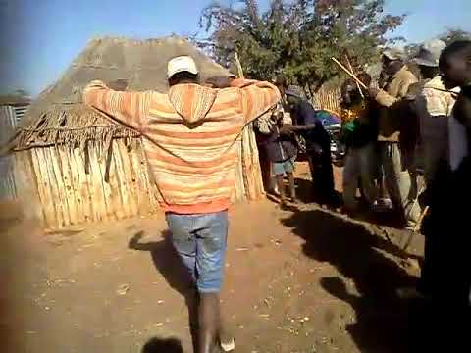

# **References:**

**Dance videos:**

**Phillipus, M. (2018, March 21). *Ompembe Oshiwambo tradition.* Retrieved from** [**https://youtu.be/BAFc_GUy9hl**](https://youtu.be/BAFc_GUy9hl)

**Johnson, S. (2015, March 17). *Traditional Owambo Dancing.* Retrieved from** [**https://youtu.be/mT0aQYixRc**](https://youtu.be/mT0aQYixRc)

**Milkyway Wedding Films [@milkyway.films]. (2019, January 28). [Video of owambo wedding dance]. Retrieved from** [**https://www.instagram.com/p/BtLVUb3DOlh/?igshid=lwoq103ya7t4**](https://www.instagram.com/p/BtLVUb3DOlh/?igshid=lwoq103ya7t4)

**Dance Images:**

**Kaakunga, R. (2018, October 15). *The Aawambo people from northern Namibia are a proud tribe with a rich culture and customs.* Retrieved from** [**https://theculturetrip.com/africa/namibia/articles/a-guide-to-the-aawambo-people-of-namibia/?dialog-open**](https://theculturetrip.com/africa/namibia/articles/a-guide-to-the-aawambo-people-of-namibia/?dialog-open)

**Johnson, S. (2015, March 17). *Traditional Owambo Dancing.* Retrieved from** [**https://www.google.com/imgres?imgurl=https://i.ytimg.com/vi/mT0aQYixR6c/maxresdefault.jpg&imgrefurl=https://www.youtube.com/watch?v%3DmT0aQYixR6c&docid=JjLyuJdLSr4IfM&tbnid=DPaWvlF237MVjM:&vet=1&w=1280&h=720&source=sh/x/im**](https://www.google.com/imgres?imgurl=https://i.ytimg.com/vi/mT0aQYixR6c/maxresdefault.jpg&imgrefurl=https://www.youtube.com/watch?v%3DmT0aQYixR6c&docid=JjLyuJdLSr4IfM&tbnid=DPaWvlF237MVjM:&vet=1&w=1280&h=720&source=sh/x/im)

**Haiduwa, A. (n.d). *Namibian Cultural Dance for Oshiwambo speaking.* Retrieved from** [**https://www.pinterest.com/pin/367676757052088602/?lp=true**](https://www.pinterest.com/pin/367676757052088602/?lp=true)

**Namibia Tourism [@NamibiaHorizons]. (2014, March 20)*. Ompembe - a cultural dance practised by males of Northern*** [***#Namibia***](https://twitter.com/hashtag/Namibia?src=hash) ***tribes whereby they jump over one another*** [***#Culture***](https://twitter.com/hashtag/Culture?src=hash)**. Retrieved from** [**https://twitter.com/NamibiaHorizons/status/446599494704975872**](https://twitter.com/NamibiaHorizons/status/446599494704975872)

16

**Authors**

1. **Masule Sulaica Priscilla**

**+264 81 719 2918 |** [**masulepriscilla@gmail.com**](mailto:masulepriscilla@gmail.com)

1. **Ntinda Maria Ndapewa**

**+264 81 200 1846 |** [**pewantinda@gmail.com**](mailto:pewantinda@gmail.com)

1. **Aludhilu Hilma Ndapewa |** [**aludhiluhilma@gmail.com**](mailto:aludhiluhilma@gmail.com)

**+264 81 404 0313**

17